Whether or not you get vaccinated, get informed!
1. Vaccination, like any medical action, requires citizen consent. Consent is not regarded as valid if it is not fully informed, nor "if it is the result of deceit, fraud or threat, or conflicts with the demands of decency" (Medical Code of Ethics, Greek law 3418/2005). Failing this, the consent is waived and the person/body who has exerted the pressure or extortion to vaccinate is subject to penal sanctions and/or civil damages in the event of harm.
2. Vaccination is not a prerequisite for the exercise of any other institutional requirement, such as education or otherwise recognized basic right such as the right to employment and free movement. Correspondingly, no private company has the legal authority to impose restrictions violating citizens' constitutional rights. Discrimination and Stigmatization are forbidden (Universal Declaration on Bioethics and Human Rights, UNESCO). Hence, the proposed “Vaccination Passport” is illegal and it constitutes indirect mandatory vaccination. Let alone that this passport has nothing to do with coronavirus: it is proposed by the EU since 2018! Finally, imposition of a medical action in any manner constitutes torture and is illegal.
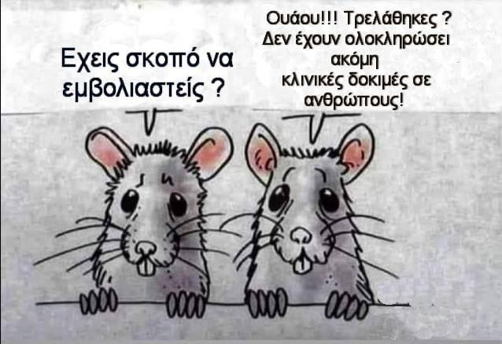
3. Non-consensual participation by citizens in medical research is specifically forbidden, as prescribed by the Nuremberg Code instituted following the trial of the Nazi-collaborator doctors. Any coercion of people to participate in research transforms them into experimental animals and amounts to a reintroduction of Nazi practices and crimes on a public health pretext. It thus constitutes Crime against Humanity (article 7, International Criminal Court Statute, Hague).
The COVID19 vaccine has an emergency license (not final approval), which means that research and clinical studies are still under way (they are to be completed in 2023)! It is INVESTIGATIONAL, as declared by the companies themselves, and any forced vaccination with it by any means (legal obligation, extortion, fraud) falls in the category of coercion in research, which is BANNED under numerous laws and international agreements and has penal and civil consequences.
4. As indicated by doctors and companies, the vaccines HAVE NOT BEEN STUDIED to determine whether they reduce viral infection or to ascertain the duration of immunity and/or the effects of their interaction with other drugs or vaccines. Therefore, neither are other people protected from infection by the virus, nor will restrictions be lifted - as is now announced.
5. The measures themselves which have been imposed are both illegal and unscientific. They are illegal in so far as they impose medical actions (e.g. the mask), they impose individual administrative measures restricting freedoms without individual legal mandate (Article 5 of the Constitution) and THEY ARE NOT EMERGENCY AND TEMPORARY (for example since June everybody talks about a second wave of viral infection, and this has already lasted for months). Τhe measures are unscientific in many ways. Specifically a) they ignore the strengthening of primary health care, which is demanded by all scientific specialists. b) they impose lockdown, which is classifiable, from a medical viewpoint, as a criminal policy (it does not reduce infections and it increases mortality from other causes, worsening health overall - mental illness, cancellation of programmed examinations and operations, c) they impose masks (which is a medical action) outdoors, which does not provide protection against the virus as they themselves assert: "they are a "symbolic measure", a slogan which says MASKS EVERYWHERE! ) d) they focus on vaccination as the only solution, instead of including the existing possibility of effective treatment with pharmaceutical drugs.
6. Doctors working with the government as advisors are evidently in receipt of funding from the same companies that are producing the vaccines: that amounts to "conflict of interest". In addition, the Prime Minister has claimed falsely that vaccination is voluntary, yet as early as 25/2/2020 the Parliament had voted the relevant laws: they are simply not in a position yet to enforce them because they do not have the vaccines.
What is most important is that citizens are denied information and doctors of alternative persuasion are muzzled, ridiculed and hounded! The mass media have already been paid for spreading this disinformation, with the 40 million euros "for strengthening information on the Corona virus" and the writing off of 30 million euros of debt. And we know that information is the most precious value in a society of freely thinking citizens.
This, informing our fellow human beings is the number one priority and a socially responsible action. Seek out the information and disseminate it freely.
- For all the above, research and data: www.nellypsarrou.com

